Pregnancy Intake Form

Name:_________________________________________________
Date:_____________ Email________________________________
Birth Date_____________ Occupation________________________
Address________________________________________________
How did you hear about us? ________________________________
Week of pregnancy ___________________ Due Date _________________

Please check off any of the following that pertain to you:
__Am over 36 years old __High blood pressure
__Heartburn __Difficulty sleeping
__First pregnancy __Placental Dysfunction
__Indigestion __Bladder or Kidney infection
__Pregnant with multiples (2+) __Varicose veins
__Constipation __Swollen feet&/or ankles
__Morning sickness, nausea
__Gestational diabetes __Leg cramps or restless legs
__High blood pressure __Phlebitis
__Threatened miscarriage __Premature Labor

List any physical disabilities, ailments, allergies, etc. that are not mentioned above:
____________________________________________________________________________________________
My goals for this massage:_________________________________________________

Please circle the areas you would like use to focus on: 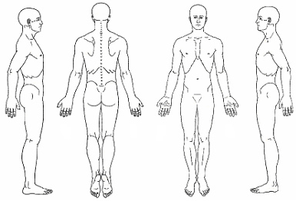

List any areas would you like us to avoid if any:
______________________________________________________________________

Do you like light, medium or firm pressure? Deep Pressure is not allowed for pregnancy massage. _____________________________________________________________

PREGNANCY MASSAGE INFORMATION AND INFORMED
CONSENT

I verify that I am experiencing a low risk pregnancy, and have stated all my known medical conditions. I have my doctor’s approval to receive prenatal massage. I understand that I will be receiving massage therapy for the purpose of stress reduction, relief from muscle tension or spasm, or for improving circulation and energy flow. I understand that the massage therapist does not diagnose illness, and, as such, the massage therapist does not prescribe medical treatment or pharmaceuticals, nor do they perform any spinal manipulations. I am aware that this massage is not a substitute for medical examination/diagnosis and that it is recommended that I see a physician for any ailment that I might have. I understand and agree that I am receiving massage therapy entirely at my own risk. In the event that I become injured either directly or indirectly as a result, in whole or in part, of the aforesaid massage therapy I HEREBY HOLD HARMLESS AND INDEMNIFY the therapist Joanna Yanez and Xochitl Codina, their
principals, and agents from all claims and liability whatsoever.

Printed name: _________________________________
Signature: ________________________Date: _________

