Postnatal Massage Intake Form

Name:__________________________________________________________
Date:_____________ Email_________________________________________
Birth Date_____________ Occupation_________________________________
Address_________________________________________________________
How did you hear about us? _________________________________________

How long ago did you deliver? _______________ Delivery Date:__________________

Please check off any of the following that pertain to you:
__Heartburn __ Insomnia
__Carpal Tunnel __Anxiety
__Indigestion __Bladder or Kidney infection
__ Sacral Pain __ Mastitis
__ Tail Bone Pain __Varicose veins
__Constipation __Swollen feet&/or ankles
__Diastasis Recti __ Sensitive/engorged Breast
__High blood pressure __Phlebitis
___Numbness in Body ___Sciatic Pain

List any physical disabilities, ailments, allergies, etc. that are not mentioned above:
____________________________________________________________________________________________
My goal for this massage is to:

_____ Relax ____Relieve Pain

Which do you prefer? Are you more comfortable lying on your side or on your stomach?

________Side lying _________Face down (on stomach)

Are you belly binding? ___Yes ____No

Would you like to learn more about this service? ____Yes _____No

Please circle the areas you would like use to focus on:
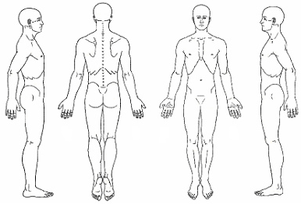

What areas would you like us to avoid, if any? ______________________________________________________________________
Is it ok to massage your scalp? ____Yes _____ No

Do you like light, medium or firm pressure? _____________________________________________________________

I understand that the massage therapist does not diagnose illness, and, as such, the massage therapist does not prescribe medical treatment or pharmaceuticals, nor do they perform any spinal manipulations. I am aware that this massage is not a substitute for medical examination/diagnosis and that it is recommended that I see a physician for any ailment that I might have. I understand and agree that I am receiving massage therapy entirely at my own risk. In the event that I become injured either directly or indirectly as a result, in whole or in part, of the aforesaid massage therapy I HEREBY HOLD HARMLESS AND INDEMNIFY the therapist, their principals, and agents from all claims and liability whatsoever.
I have my doctor’s approval to receive massage. I herby give permission to Joanna Yanez LMT, Joanna Yanez Jr, and or Xochitl Codina to apply massage.

Printed name: ____________________________________________________
Signature: ________________________Date: __________________________

